**Experiment: 02 Date: 15th Feb 2023**

**Aim: Test Plan for LinkedIn Website**

The purpose of this test plan is to ensure that LinkedIn website is functioning properly and efficiently. This test plan provides the scope, objectives, resources and schedule for testing LinkedIn website.



**Scope:**

The LinkedIn website will be tested for its functionality, usability, performance, security, and compatibility across different devices and browsers. The testing will cover the following areas:

* Sign up and login process
* Profile creation and management
* Messaging and connection requests
* News feed and posts
* Job search and application
* Groups and community interaction
* Premium features and benefits

**Objectives:**

The objectives of this test plan are:

* To identify and report defects or issues in the LinkedIn website
* To ensure that the website is user-friendly and easy to navigate
* To ensure that the website meets the functional and non-functional requirements
* To ensure that the website is secure and protects user data
* To ensure that the website is compatible across multiple devices and browsers
* To ensure that the website provides a consistent user experience

**Resources:**

The following resources will be required for testing LinkedIn website:

* Testers
* Test environment with different devices, browsers, and operating systems
* Test data and user accounts
* Test management and defect tracking tools



**Test Approach:**

The following approach will be used for testing LinkedIn website:

* **Functional Testing:** This will involve testing the website’s features and functionality to ensure they work as intended.
* **Usability Testing:** This will involve testing the website’s ease of use, navigation, and overall user experience.
* **Performance Testing:** This will involve testing the website’s speed, response time, and scalability.
* **Security Testing:** This will involve testing the website’s security measures and ensuring that user data is protected.
* **Compatibility Testing:** This will involve testing the website’s compatibility across different devices, browsers, and operating systems.
* **Regression Testing:** This will involve re-testing previously tested areas of the website to ensure that changes made to the website do not impact existing functionality.

**Test Schedule:**

The following schedule will be used for testing LinkedIn website:

* **Test Planning:** 2 days
* **Test Execution:** 10 days
* **Test Reporting:** 2 days

**Deliverables:**

The following deliverables will be produced during the testing of LinkedIn website:

* Test plan document
* Test cases document
* Test execution report
* Defect tracking report
* Test summary report

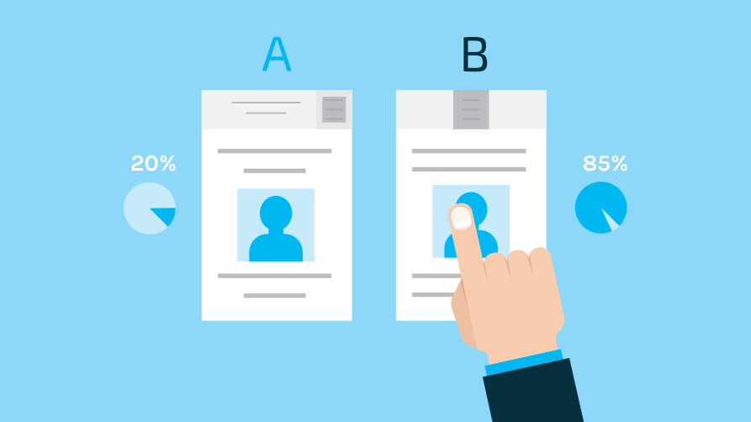

**Risks and Mitigations:**

The following risks have been identified and mitigation measures will be taken to minimize their impact:

* **Network or server outage during testing** - Test will be rescheduled once the issue is resolved.
* **User data leakage or data breach** - Testing will be done in a controlled environment and all user data will be deleted after the testing.
* **Lack of testing resources -** Additional resources will be assigned to complete the testing as per schedule.
* **Changes to the website during testing** - Testing will be re-planned to cover any changes made to the website.

**Conclusion:**

This test plan will ensure that the LinkedIn website is thoroughly tested and meets the required quality standards. The test results and reports will provide valuable insights and recommendations for improving the website’s functionality, usability, and overall user experience.